**Project Design Phase-II**

**Data Flow Diagram & User Stories**

|  |  |
| --- | --- |
| Date | 14 October 2022 |
| Team ID | PNT2022TMID37949 |
| Project Name | Project – SMART WASTE MANAGEMENT |
| Batch | B9-3A5E |
| Maximum Marks | 4 Marks |

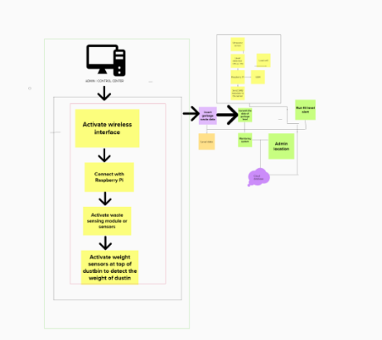

**User Stories**

Use the below template to list all the user stories for the product.

| **User Type** | **Functional Requirement (Epic)** | **User Story Number** | **User Story / Task** | **Acceptance criteria** | **Priority** | **Release** |
| --- | --- | --- | --- | --- | --- | --- |
| Admin (who manage web server) | Login | USN-1 | As an admin, I gave user ID and password for workers and manage them. | I can manage web account /dashboard | Medium | Sprint-2 |
| Co-admin | Login | USN-2 | As a Co-admin, I’ll track the level of the garbage bins with unique ID. When the level reaches the threshold limit and provide location access to clean the dustbins. | I can monitor the garbage | High | Sprint-1 |
| Truck driver | Login | USN-3 | As a truck driver, I ‘ll follow the route send by Co-admin to reach filled garbage location. | I can give the shortest route to reach the garbage filled location. | Medium | Sprint-2 |
| Garbage collector | Login | USN-4 | As a garbage collector, I’ll collect all the trash into garbage truck and send it to dumping ground. | I can collect the trash and drag to truck and send off | Medium | Sprint-2 |
| Municipality | Login | USN-5 | As a municipality, I’ll check the process is happening in good manner without any issues. | I can manage all the process are going in discipline manner. | High | Sprint-1 |